CAPPA Pre-Training Assignment
For Labor Doula Certification Training Classes
This guide is to help you prepare for the Labor Doula Training Class. Please complete this assignment prior to your class and submit to your instructor one week prior to the training. Please type your answers and email your assignment to your instructor. You may use internet or printed sources to research your answers, in particular your required reading. Please do not cut and paste; answer in your own words. If you are an RN who has been actively working in L&D for at least one year, you qualify to complete questions 1-14 only. Otherwise, all questions must be completed. This assignment is considered a mandatory part of your training class.

Please view the videos at the links below, using password April2017.
Video 1 - https://vimeo.com/209838148

Video 2 - https://vimeo.com/209844063

Video 3 - https://vimeo.com/209841609

DO NOT share the videos and password with anyone, as it is only for students registered for Labor Doula training with CAPPA. Listen for the three secret phrases! Answer the next 12 questions using the video and reviewing the content on the CAPPA website. Please answer in your own words.
- The three secret phrases are ____________________________, ____________________________, and _________________________________.

- Why did you choose CAPPA?

- Describe the Four Cornerstones of the CAPPA Approach. How does your personal philosophy compare to the CAPPA Approach?

- What are some of the highlights of the CAPPA Code of Conduct and Social Media Policy?

- What is the purpose of the Grievance Policy? How would someone file a grievance?

- Why is certification important?

- List the certification steps.

- What is required for recertification?

- Describe the CAPPA Labor Doula Scope of Practice and the major points.

- List five things that are outside the scope of practice of a CAPPA labor doula.

- How does a labor doula support a mother and her family in pregnancy, birth, and postpartum?

- Who is the CEO of CAPPA? Who is the Executive Director of Labor Doula Programs?

- Where does the term “doula” come from and what does it originally mean?

- Please acknowledge by signing or typing your name: I understand that I may not use CAPPA’s name as title for myself or my business (such as “CAPPA trained”) as the use of CAPPA’s name is only permitted after certification is earned. I understand that using the titles CLD or CAPPA Certified Labor Doula (or any variation thereof) prior to officially earning my certification from CAPPA will result in being permantly disqualified from being certified. ________________________________________

- Describe the function during pregnancy and birth of each item labeled on the diagram below.
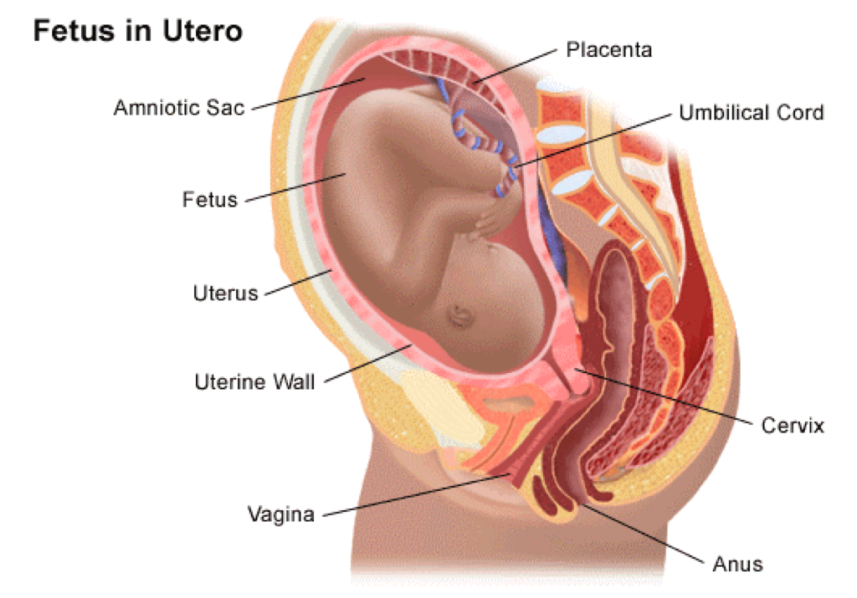
  - Amniotic Sac
  - Fetus
  - Uterus
  - Vagina
  - Placenta
  - Umbilical Cord
  - Cervix
  - Anus

- Identify the following from the pelvis model below:
      - _____ _____
      - ___________
      - ___________
      - _____ _____
      - _____ _____
      - _____ _____
      - _____-_____ joint
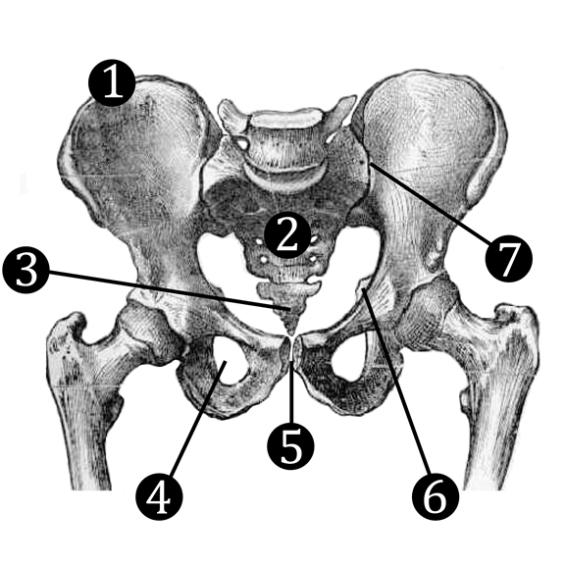
- Identify and describe 5 pre-labor signs that may be experienced in the last weeks of pregnancy.
- Describe the hormones involved in pregnancy and labor.
- Define effacement and dilation in terms of labor and birth. Describe how they are measured.
- List the stages and phases of labor, and describe what happens during each.
- Physiologically, what happens during a uterine contraction? Describe the muscle action and its purpose.
- In your own words, describe 3 relaxation techniques that can be used in labor, and describe the role relaxation plays in labor.
- List 5 reasons cesareans are performed.
- What is a VBAC? How does it change the birthing woman’s options?

- What do you feel are the most important reasons for breastfeeding?
- Describe perinatal mood disorder and some of the risk factors that increase its likelihood.
- What are the laws regarding midwifery and out-of-hospital birth in your state? What birthing options are available in your area?

Define the following:
Explain these terms:
Group B Strep
Occiput Anterior or OA
Occiput Posterior or OP
APGAR
Station
Explain each of the following terms:
External Fetal Monitoring
- Purpose:
- Benefits:
- Risks:
Internal Fetal Monitoring
- Purpose:
- Benefits:
- Risks:
Episiotomy
- Purpose:
- Benefits:
- Risks:
Epidural Anesthesia
- Purpose:
- Benefits:
- Risks:
Spinal Anesthesia
- Purpose:
- Benefits:
- Risks:
Pitocin
- Purpose:
- Benefits:
- Risks:
Cytotec
- Purpose:
- Benefits:
- Risks:
Foley or Cook Catheter (used for induction)
- Purpose:
- Benefits:
- Risks:
Amniotomy
- Purpose:
- Benefits:
- Risks:
Forceps
- Purpose:
- Benefits:
- Risks:
Vacuum Extraction
- Purpose:
- Benefits:
- Risks:

